UGANDA THE PEARL OF AFRICA
Class Bird Trip
July 30 to 20 August 2023
Uganda is one of the richest countries in Africa for birds, with over a thousand species being recorded. This diversity results from Uganda’s position on the Equator at the crossroads of the plains of East Africa and the rainforests which dominate much of West Africa. It is a country of varied and beautiful landscapes with forests, natural lakes, and the source of the Nile. Our tour takes in the premier regions for birds including the Impenetrable Forest at Bwindi and the rich forest habitats of Semliki. This trip to ‘The Pearl of Africa’ is bound to produce a long birdlist as well as close sightings of primates and mammals. Interesting species recorded on previous visits include the impressive Shoebill, White-spotted Flufftail, African Dwarf Kingfisher, Brown-chested Lapwing, Chocolate-backed Kingfisher, Black Bee-eater, Papyrus Gonolek, Doherty’s Bushshrike, Papyrus, Grauer’s and Short-tailed Warblers.
Dates: July 30 to August 20 2023; Leader: John Sterling; Co-leader: Hamlet Mugabe; with local guides at several locations Group Size: Six - eight; Trip Category: Serious Birding; No. of days: Twenty-two (22); Price: $8,000; Expected No. of birds: 600-750; Ground transport: Customized Four-Wheel Drive Land-cruiser with a pop-up roof.
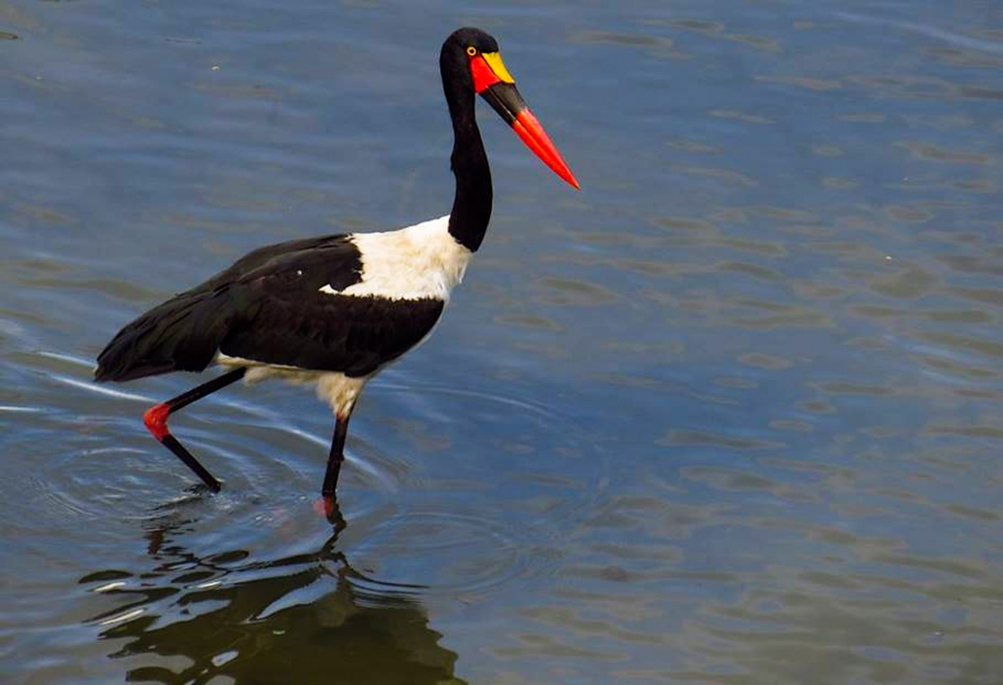
Saddle-billed Stork at the shores of Lake Victoria
Day 1: (July 30. 2023) Arrival at Entebbe International Airport you will be welcomed by Hamlet and the driver and will be transferred to Entebbe town for an overnight stay. After resting and freshening up we visit Entebbe Botanical Gardens adjacent to Lake Victoria. The larger trees attract Grey Woodpecker, Great Blue and Ross’s Turacos, Black and White Casqued Hornbills, Red-bellied Paradise Flycatcher, Black-necked and Spectacled Weavers, and Eastern Black-headed Oriole. Riverside trees hold Orange-tufted, Green-throated, and Red-chested Sunbirds and a range of weavers including Slender-billed, Orange, Northern Brown-throated, and Yellow-backed. Dinner and overnight stay at Imperial Botanical Beach Hotel.
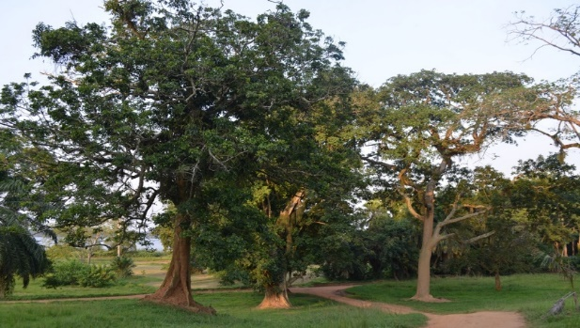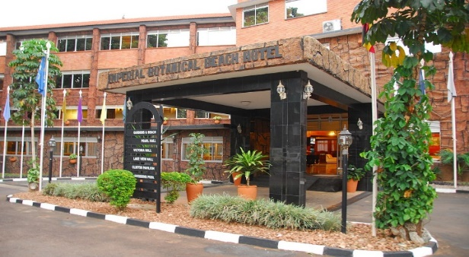
Entebbe Botanical Gardens Imperial Botanical Gardens Hotel Entebbe
Day 2: (July 31. 2023) Today we visit Mabamba village and its adjacent swamp. This is one of the few remaining swamps in Uganda protected by the local communities. It is an extensive papyrus swamp with its labyrinth of channels and lagoons, classified as an Important Bird Area, and a favorite place for shoebills
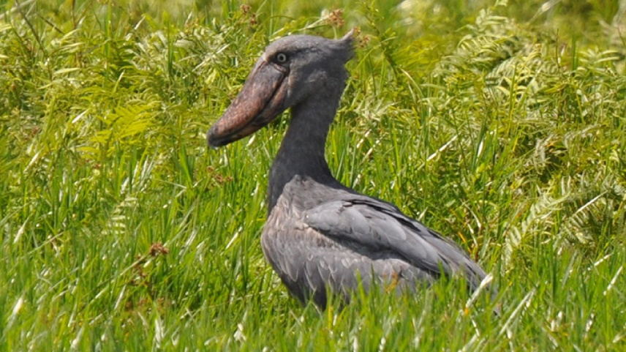
Shoebill at Mabamba bay at Lake Victoria shores
The entrance road winds its way through areas of secondary forest and agricultural land attracting Madagascar Bee-eater, Red-headed Lovebird, Black-necked, and Weyn’s Weavers. We enter Lake Victoria in hand-paddled boats, exploring a maze of channels and mudflats for Shoebill, African Marsh Harrier, Allen’s Gallinule, Lesser Jacana, Blue-breasted Bee-eater, Winding Cisticola, and White-winged Warbler. Later in the day, we transfer to Lake Mburo National Park for a two-night stay. Overnight stay at Arcadia Cottages
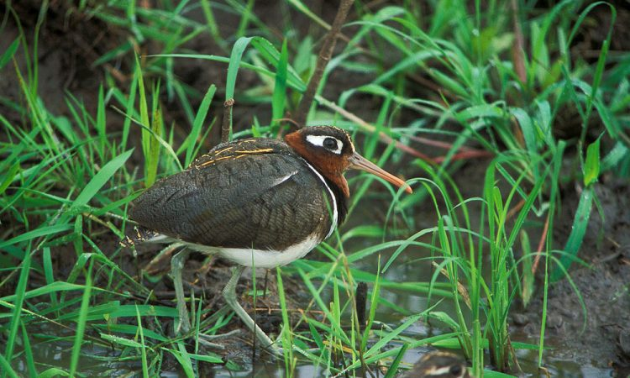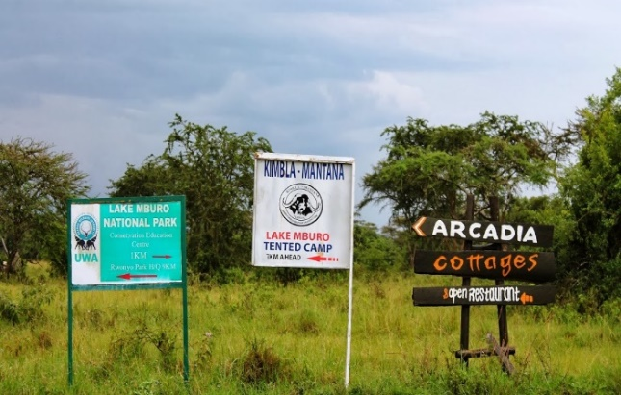
Greater Painted-snipe
Day 3: (August 01. 2023) A day exploring Lake Mburo National Park, an area of wetlands and acacia forests. Grassy fields scattered with acacia trees lure Senegal Lapwing, Bare-faced Go- away-bird, Eastern Grey Plantain-eater, and White-winged Tit. We take a boat trip on the lake for White-backed Night Heron and African Finfoot. In the park itself, an exploration of tracks and reed-lined swamps may produce Nubian Woodpecker, Yellow-breasted Apalis, Spot-flanked and Black-collared Barbets. At Nshara Gate, a large seasonal marshland has Rufous-bellied Heron, African Water Rail, and Three-banded Plover. Drier areas attract Crested Francolin, Red-faced, and the rare, Long-tailed Cisticola, Yellow-throated Long-claw, and Golden-breasted Bunting, Brown-chested Lapwing. A night game drive is also possible here to look for African Scops Owl, Verreaux’s Eagle-Owl, and Black-shouldered, Fiery-necked, and Pennant-winged Nightjars
Overnight stay at Arcadia Cottages
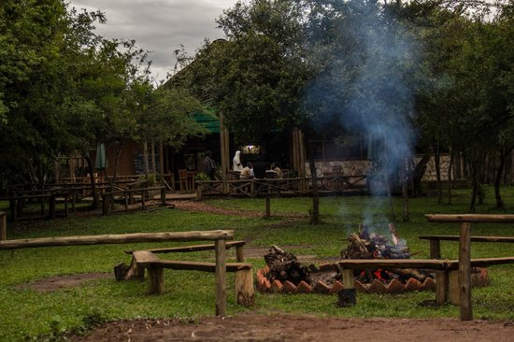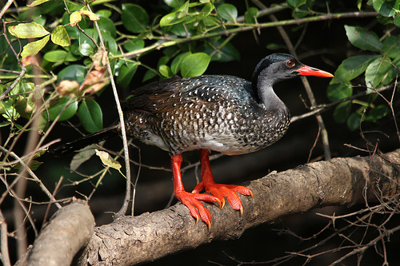
Arcadia cottages – Lake Mburo NP African Finfoot
Day 4: (August 02. 2023) “Lake Mburo wilderness nature walk and transfer to Mgahinga Gorilla NP”. After breakfast, before our departure to Mgahinga National Park we take a wilderness nature walk in Lake Mburo National Park. The park is also home to large numbers of African fish eagles. There is also a wide variety of savannah and waterfowl including some spectacular species such as Narina's Trogon, Ross's Turaco, African Green Pigeon, the Bare-faced Go-awaybird, Nubian Woodpecker, Spot-flanked Barbet, Emerald-spotted Wood Pigeon, African Marsh Harrier, African Hawk-Eagle, Water Thick-knee, Red-faced Barbet, Black Cuckoo Shrike, Song, Long-tailed, and Siffling Cisticola, Yellow-fronted Tinkerbird, Yellow-spotted Barbet, Black-collared Barbet, and Double-toothed Barbet, African Penduline Tit, African Black-headed Oriole, Tropical Boubou, Southern Red Bishop, Brubru, and Holub’s Golden Weaver. Search the park's swamps for mysterious papyrus species such as the Papyrus Gonolek. The walk is good and gives us close encounters with large mammals including the endangered Rothschild giraffe on foot.
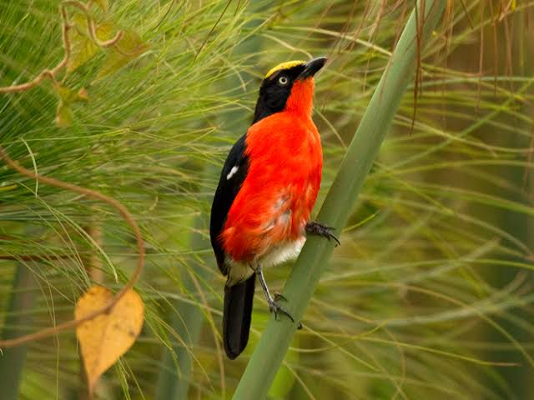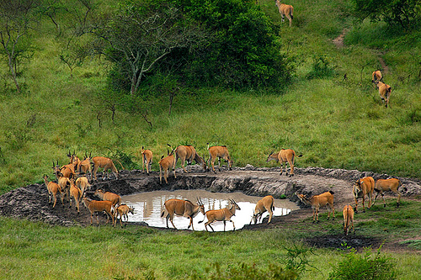
Papyrus Gonolek Great Eland at a waterhole in L. Mburo NP

At 10 am we travel to Mgahinga National Park is Uganda’s smallest national park located in the great Virunga ranges shared between Rwanda, Uganda, and the Democratic Republic of Congo. Found in Kisoro district the park is home to three popular volcanoes of Mgahinga, Sabinyo, and Muhavura. On our way to Mgahinga, we will drive through Echuya Forest Reserve a fantastic birding site located at a high altitude in the southwestern part of the country near the Rwandan border. The forest is home to roughly 150 species of birds, eighteen of which are endemic to the Albertine rift, including the elusive Grauer's Swamp warbler other species include Shelley’s and Mountain Greenbuls, Grey Cuckoo Shrikes, and White-starred Robins White-browed Crombec, Mountain Masked Apalis, Chestnut-throated Apalis, Red-headed Bluebills, Montane Black-headed Oriole, Rwenzori Batis, Red-throated Alethe, African Goshawk, Augur, Common, and Red-necked Buzzards, Long-crested Eagles and Goshawks after birding here descend the volcanic mountain ranges to Kisoro town for an overnight stay at Traveler’s Rest Hotel
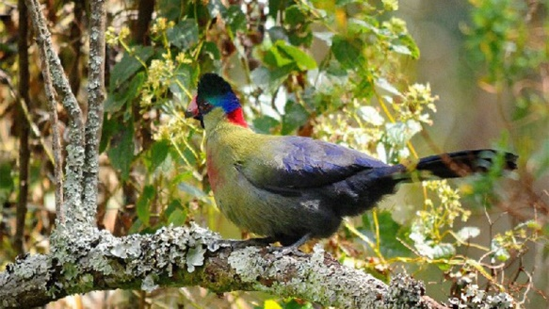
Rwenzori Turaco
Day 5: (August 03. 2023) “Whole day birding Mgahinga Gorilla National Park”. The best birding in Mgahinga also takes in some of its most beautiful scenery in the gorge between Mt Gahinga and Sabinyo, through the bamboo forest, and in the montane forest, where the beautiful Rwenzori Turaco may be observed. The three to four-hour Gorge Trail between Gahinga and Sabinyo can provide spectacular sightings of the Dusky Turtle Dove, Cape Robin-chat, Kivu-ground Thrush, Olive Thrush, Brown-crowned Tchagra, Bronze Sunbird, Regal Sunbird, Blue-headed Sunbird, Rwenzori Batis, Black-headed Waxbill, and Streaky Seedeater. The best viewing trail in Mgahinga includes the George trail and the bamboo trail. The Bamboo trail is found in the montane forest which is at 2660-2700 meters above sea level and covers an area of 2500meters. This bamboo belt is one of the best sites to spot Rwenzori Turaco. The trail offers Chubb’s Cisticola, Red-faced Woodland Warbler, Banded Prinia, Doherty’s Bush-shrike, and Lagden’s Bush-shrike are vocal yet inconspicuous inhabitants of the tangled vegetation at the forest’s edge. Accommodation options; Traveler’s Rest Hotel
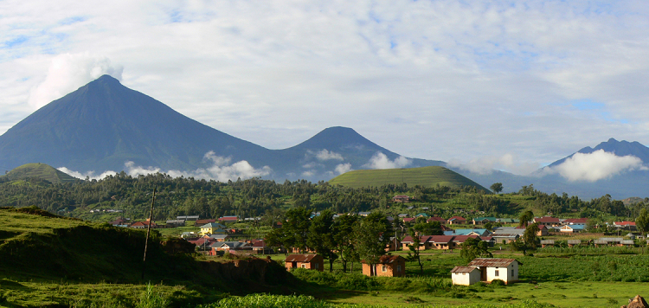
Mgahinga Gorilla National Park is on the mountain you see in the middle. These are volcanic mountains on the border of Rwanda, Uganda, and Eastern DRC.
Day 6: (August 4, 2023) After breakfast travel to Ruhija the southern sector of Bwindi Impenetrable NP which is situated at an elevation of 2300m. As we ascend in height we should find Augur Buzzard, Olive Pigeon, Thick-billed Honeyguide, Chestnut-throated and Rwenzori Apalis’s, Doherty’s Bushshrike, Mountain Oriole, Regal, and Blue-headed Sunbirds. Overnight stay at Gorilla Mist Lodge or Ruhija Gorilla Lodge
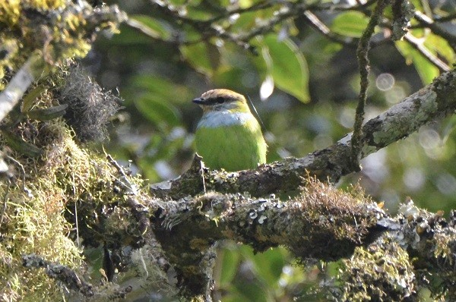
African Green Broadbill
Day 7: (August 5, 2023) “Whole day birding Mubwindi swamp trails” Ruhija the southern sector of Bwindi has many important birding areas. During our stay, we intend to explore several trails and habitats. Along the main track, we may find Handsome Francolin, Mountain Greenbul, White-browed Crombec, African Hill Babbler, Collared Apalis, Banded Prinia, and the scarce Grauer’s Warbler. In areas of grasses and thickets, we search for Shelley’s Crimsonwing, Mountain Illadopsis, Archer’s Robin-Chat, Cinnamon Bracken, and Mountain Yellow Warblers. The trail to the Mubwindi Swamp offers opportunities for spotting African Green Broadbill, Yellow-eyed Black Flycatcher, Grauer’s Warbler, Lagden’s Bush-shrike, Stripe-breasted Tit, at the swamp, we spot Grauer’s Swamp Warbler, Red-chested Flufftail and Africa Water Rail. Overnight stay at Gorilla Mist Lodge or Ruhija Gorilla Lodge
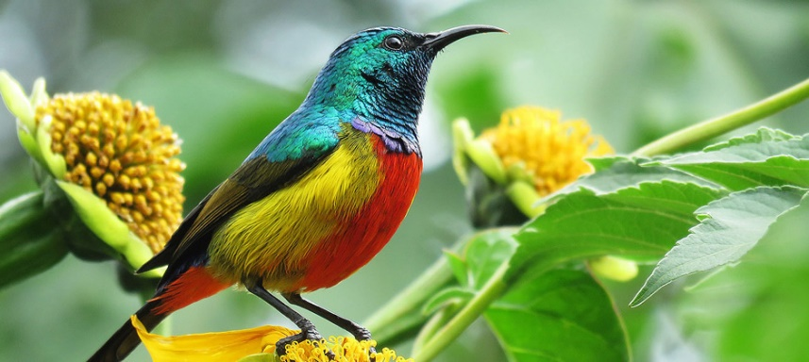
Regal Sunbird
Day 8: (August 6, 2023) The Neck is an important habitat for birds and we may see Grey-headed and Little Green Sunbirds, Dusky Blue Flycatcher, Pink-footed Puffback, and the poorly known Lagden’s Bushshrike. The river has Mountain Wagtail and Cassin’s Flycatchers. Our journey takes us to Bwindi Impenetrable National Park straddling the border with Congo. Our journey takes us to Kabale and over highlands reaching almost 2500 meters. Specialties include Augur Buzzard, White-headed Woodhoopoe, Black-crowned Waxbill, Thick-billed Seedeater, and Chubb's Cisticola. We eventually reach Bwindi, a huge montane forest, for a two-night stay at Overnight stay at Buhoma Community Rest Camp
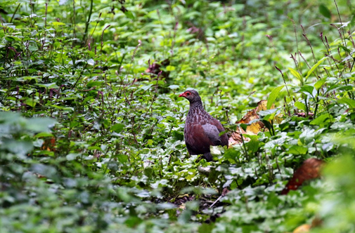
Handsome Francolin
Day 9: (August 7, 2023) Bwindi Impenetrable Forest is exceptionally rich in forest species restricted to the Albertine Rift covering Uganda, Rwanda, and Congo. Walking along forest trails is a wonderful natural experience with hundreds of colorful butterflies and areas of streams and tumbling waterfalls. Bwindi offers some of the best forest birding in Africa. The campgrounds before the main track attract Black Saw wing, Petit's Cuckoo-shrike, Vanga Flycatcher, Mackinnon's Fiscal, Luhder's Bush-shrike, Black-billed Weaver, Variable Sunbird, and Grey-crowned Negrofinch. On the main track, we enter the forest with its huge trees and lichen-lined trunks a reliable area for White-tailed and Red-throated Alethe, Black-faced Rufous Warbler, and Yellow-eyed Black Flycatcher. Other species recorded on recent visits have included Crested Guineafowl, Black Bee-eater, Elliot's Woodpecker, Yellow-throated, Yellow-rumped, and Speckled Tinkerbirds, Grey-throated and Yellow-spotted Barbets, Equatorial Akalat, White-tailed Crested-flycatcher, Sooty Flycatcher, Stuhlmann's and Waller's Starlings, Slender-billed, Plain, Little, Shelley's and Yellow Whiskered and Red-tailed Greenbuls, Green-throated Sunbird and Brown-capped Weaver. Overnight stay at Buhoma Community Rest Camp
Day 10: (August 8, 2023) “Mountain Gorilla Tracking” Over half of the world's population lives in Bwindi Impenetrable National Park, and three of the family groups live near the park headquarters in Buhoma, the northern part of the park. Visited groups of gorillas have been successfully habituated to being approached by humans. After an early breakfast, we head to the park headquarters with our packed lunches for a pre-gorilla tracking briefing from the ranger guides. At the information center, visitors are divided into groups that can be led by the ranger guides to track and reach gorillas for up to an hour. The mountain gorillas are undoubtedly the main attraction of Bwindi Forest. These endangered mountain gorillas are gentle giants and seeing them is one of the most exciting life experiences of all time. They are fascinating primates to watch and watching and photographing them with their surprisingly human-like interactions is an unforgettable experience, an experience not to be missed. Depending on where the gorillas are on any given day, the trek can be over uneven terrain and can last from short to long hours in a day, around 2 to 8 hours.
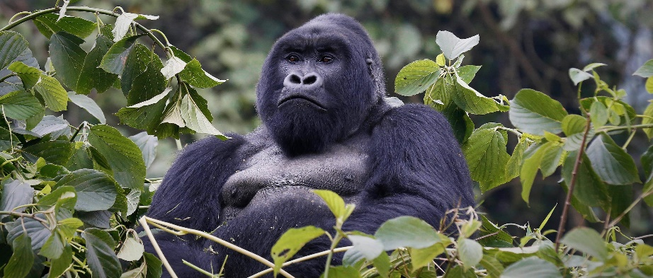
The endangered Mountain Gorilla – Bwindi Impenetrable National Park
We will move off the beaten track through the dense forest, but we will also constantly move up and down the plant-covered slopes of rugged hills. At the end of the day, we will surely appreciate why this forest earned its name, but it will be worth the effort! Once the gorilla family has been found, our tracker and ranger guides will keep our distance at a comfortable 5 meters where we will have a close view of the dense vegetation; an exciting and truly unforgettable experience. You will settle into their environment and enjoy one (1) hour stay with them while leisurely observing and photographing these fascinating humble primates whose habits and gestures remind us so much of our own. The meeting can be different and each has its own rewards; You'll enjoy watching the adult animals up close as they feed, groom and rest, while the young gorillas swing and swing from the vines in a delightfully lively performance. These habituated gorillas usually ignore human presence, but you never know when you'll make eye contact or a playful boy will come along to examine you! Remember to prepare with sensible hiking or jungle boots and clothes blending the forests and don’t your cameras. After gorilla tracking we will return to the lodge for refreshments and relaxation in the evening around 4 pm, we go birding along the river trail adjacent to the park a short distance to the park boundary. Overnight stay at Buhoma Community Rest Camp
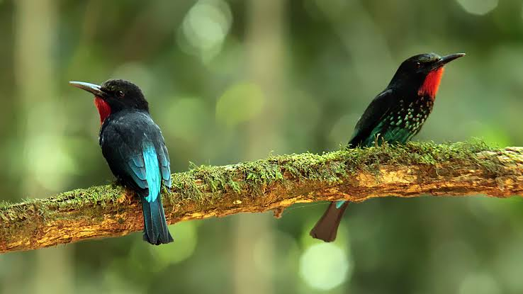
Black Bee-eater
Day 11: (August 9, 2023) After early breakfast drive to the Ishasha sector of Queen Elizabeth National Park, spend a whole day birding in this beautiful savanna landscape, look for Pearl-spotted Owlet, Martial Eagle, Bateleur, Grassland Pipit, Flappet Lark, Verreaux’s Eagle, Spotted Eagle Owl, European Bee-eaters, Rufous-naped Lark, Trilling and Croaking Cisticolas, Alpine Swift, Narina’s Trogon, White-headed, and Double-toothed Barbets. On the river’s edge lookout for Giant Kingfisher, Swamp Flycatcher, Woodland Kingfisher, herons, plovers, during our birding we should encounter other wildlife like tree-climbing lions, buffalos, hyenas, Uganda Kob, Topis, Hippos, Elephants and Leopards. Later evening drive should offer us nightjars like Pennant-winged Nightjar, Black-shouldered Nightjar, Square-tailed Nightjar, Plain Nightjar. Meals and Overnight at Enjojo Safari Lodge or Topi Lodge.
Day 12: (August 10, 2023) After early breakfast travel to Mweya Peninsula in the Northern sector of Queen Elizabeth National Park birding en route. Our journey takes us through the southern sector of the park. At Ishasha, a remote camp-ground, we look for Black Cuckoo-shrike, Yellowbill, and African Firefinch. The road passes (seasonal) pools with Red-billed Duck, Hottentot Teal, and Greater Painted-snipe. We eventually reach the Kazinga Channel, linking Lake George and Lake Edward, and our base at The Bush Lodge, an idyllic location set on its own grounds. Two-night stay at The Bush Lodge
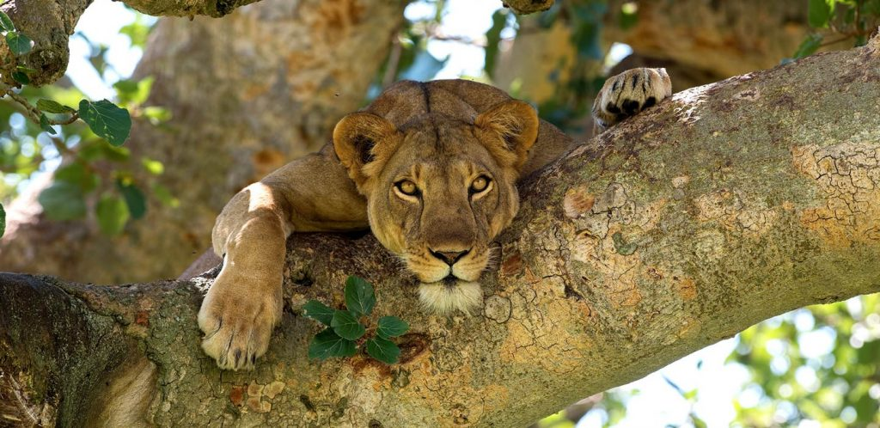
Tree-climbing lions in Ishasha sector
Day 13: (August 11, 2023) We have a full day exploring Queen Elizabeth National Park and the northern sector, an area of savanna, bush, river, and lake habitats. The hotel gardens have Grey-headed Kingfisher, Swamp Flycatcher, Black-headed Gonolek, Grey-capped Warbler, and Slender-billed Weaver. We take an early morning game drive towards the Kasenyi Track. Along the road, we should find Scaly Francolin, Crowned Lapwing, Harlequin Quail, and Common Button-quail. Larks are numerous and comprise Rufous-naped, Flappet, and the localized White-tailed Lark. Raptors we aim to locate include Lappet-faced and White-backed Vultures, Martial Eagle, Banded Snake Eagle, and Bateleur. Wet grassland may hold Broad-tailed and African Moustached Warblers, Trilling and Croaking Cisticolas, Marsh Tchagra, Fawn-breasted, and Crimson-rumped Waxbills. Acacia trees are home to Black-headed Batis, Sulphur-breasted Bushshrike, and Red-shouldered Cuckoo-shrikes. In the afternoon, we embark on a boat trip down the Kazinga Channel. This is an incredible area for waterbirds, giving us close views of Saddle-billed Stork, African Spoonbill, Water Thick-knee, and African Skimmer. The Bush Lodge
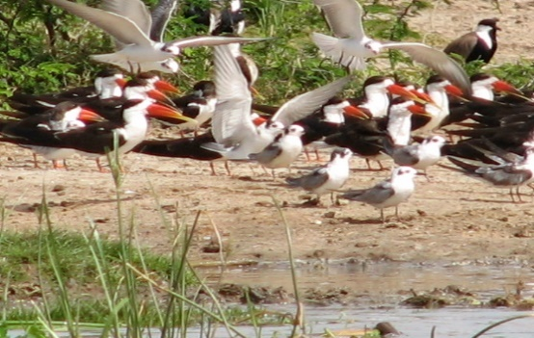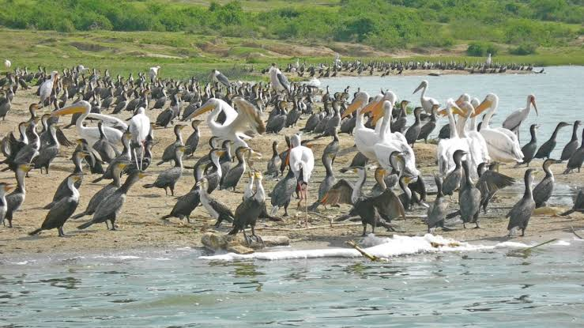
African Skimmer (left) and (Right) Pelicans, Comorants and stark on the shores of Kazinga Channel Queen Elizabeth NP
Day 14: (August 12, 2023) “Jacana sector and travel to Kibale NP” On this day with our luggage in the vehicle, we go birding at Jacana forest before our departure to Kibale National Park. Jacana section is part of Queen of Elizabeth National Park which has crater lakes that are enclosed by the forest and a patch of the forest should offer us Black Bee-eater, Western Nicator, and several Greenbuls along the stream that flows from one of the crater lakes should offer us Shining Blue Kingfisher, Pink-backed Pelican, and other forest birds. At around 11 am travel to Kibale National Park with a hot lunch en route and afterward proceed to the park with en-route birding. Late evening at camp offers African Wood-Owl, Dinner, and Overnight at Kibale Forest Camp
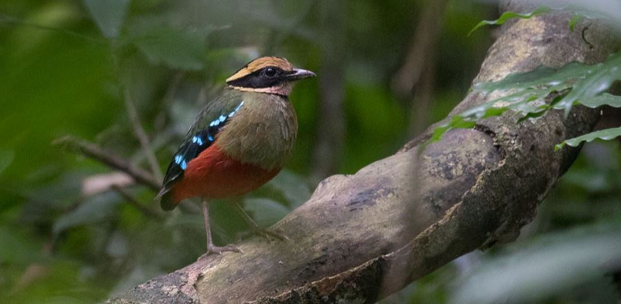
Green-breasted Pitta
Day 15: (August 13, 2023) “Whole day at Kibale and Bigodi wetland”. After early breakfast, we enter the park to look for the forest birds of Kibale National Park and later after lunch visit Bigodi wetland sanctuary. In the forest, we should spot the Green-breasted Pitta a scarce Inter-African migrant. Other species occurring in the park include Black Goshawk, Olive Long-tailed Cuckoo, Blue-throated Roller, Brown-chested Alethe, Dusky Tit, Woodhouse’s Antpecker, and many others. The forest also gives us our best chances of observing chimpanzees which reside in good numbers. Afternoon visit Bigodi a wetland mixed vegetation with papyrus reeds, forest trees, and grass look-out for White-collared Olive-back, Papyrus Gonolek, Toro-olive, and Honey-guide Greenbuls, Woodpeckers, Turacos, Waxbills, Flufftails, tits, saw-wings, bee-eaters and thrushes. Dinner, and Overnight at Kibale Forest Camp
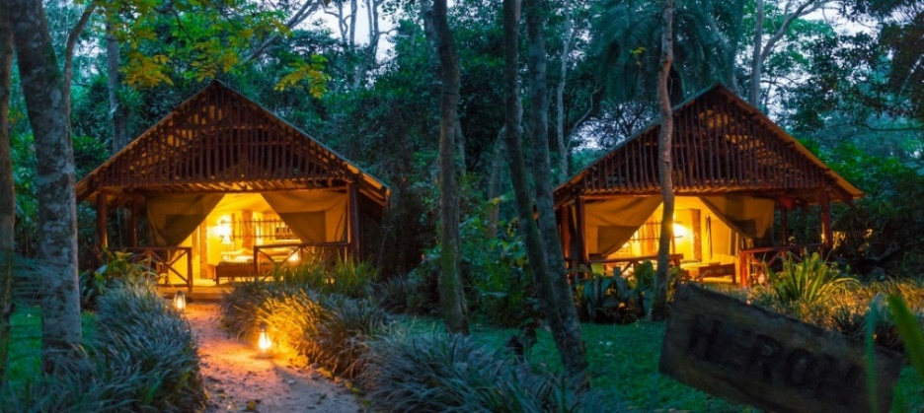
Kibale Forest Camp
Day 16: (August 14, 2023) “We will spend 2 nights in Semliki forest birding the Kirumia trail and the forest in general”. Have an early breakfast and with our lunch packs, travel to Semliki National Park approximately 2 hours and 30 minutes from Kibale forest. Semliki National Park has numerous trails running through the humid forest which are productive for White-bellied kingfisher, We look out for a number of predominantly Central African species which cannot be found anywhere else in East Africa yet are some of the continent’s most spectacular and sought-after birds such as; Long-tailed Hawk, Congo Serpent Eagle, Lyre-tailed Honeyguide, the Black-Casqued Wattled, Piping, Red-billed Dwarf, and White-crested Hornbills, the Nkulengu Rail, and other species; Blue Swallow, White-throated Blue Swallow, Swamp Palm Bulbul, Spotted Greenbul, White-starred Robin, Lowland Akalat, Red-throated Alethe, Fire-crested Alethe, Snowy-headed Robin-Chat, Blue-shouldered Robin-Chat, Red-eyed Puffback, White-tailed Robin-Chat, Northern Bearded Scrub-Robin, Capped Wheatear, Common Stonechat, Abyssinian Ground-Thrush, Oberlaender’s Ground-Thrush, Grey Ground-Thrush, Little Grey Greenbul, Toro Olive Greenbul, Mountain Greenbul, Yellow-throated Nicator, Western Nicator, Spot-breasted Ibis, Hartlaub’s Duck, Chestnut-flanked Goshawk, Red-thighed Sparrowhawk, just to mention but a few. There is a single, unconfirmed report of the globally threatened Lesser Kestrel. Overnight stay at Bumaga cottages at Semliki National Park.
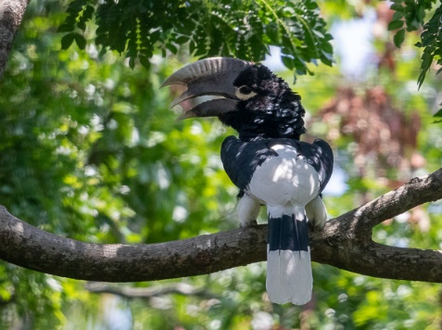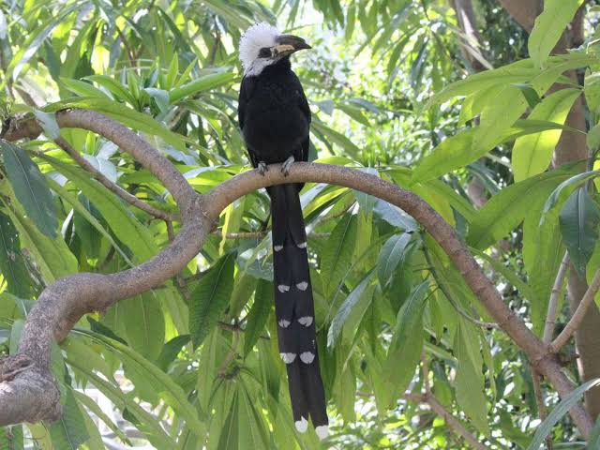
White-thighed Hornbill White-crested Hornbill
Day 17: (August 15, August) “Whole day birding the forest and around the hot springs” Today we look for Black-casqued, Black Dwarf, and Red-billed Dwarf Hornbills, Forest Robin, African Piculet, Red-rumped Tinkerbird, Brown-chested Alethe, Yellow-throated Nicator, Xavier’s Greenbul and Chestnut Wattle-eye. Rarer species we hope to find include Hartlaub’s Duck, Long-tailed Hawk, Black-collared Lovebird, Yellow-throated Cuckoo, Spotted and Lyre-tailed Honeyguides, Rufous-sided Broadbill, Blue-headed Crested Flycatcher, and Grant’s Bluebill. Semliki also has habitats of grassland dotted with scrub and palms attracting another wide range of birds. Long-tailed Hawk, Forest Francolin, Nkulengu Rail, Western Bronze-naped Pigeon, Black-collared Lovebird, Yellow-throated Cuckoo, Red-chested Owlet, Bates’ Nightjar, Chocolate-backed, White-bellied and African Dwarf Kingfishers, White-crested, Red-billed Dwarf, Piping and Black-wattled Hornbills, Red-rumped Tinkerbird, Spotted, Lyre-tailed and Zenker’s Honeyguides, African Piculet, Gabon Woodpecker, White-throated Blue Swallow, Green-tailed Bristlebill, Sassi’s Olive, Xavier’s, Swamp, Simple and Eastern Bearded Greenbuls, Yellow-throated Nicator, Capuchin Babbler, Northern Bearded Scrub-Robin, Forest and Grey Ground Thrushes, Lemon-bellied Crombec, Brown-crowned Eremomela, Blue-headed Crested Flycatcher, Ituri Batis, Red-billed Helmet -Shrike, Red-eyed Puff-back, Black-winged Starling, Maxwell’s Black Weaver, Blue-billed, Crested and Red-bellied Malimbes, Pale-fronted and Chestnut-breasted Negro finches, Grant’s Bluebill.
Overnight stay at Bumaga cottages at Semliki National Park.

Day 18: (August 16, 2023) “Travel to Masindi-Budongo forest” After breakfast, we head towards Masindi along a newly constructed tarmac road. An agricultural area close to a village offers us Speckle-breasted Woodpecker, Lesser Honeyguide, Brown-crowned, and Black-headed Tchagras, Green-throated and Purple-banded Sunbirds. As we approach Masindi, forest patches may produce Grey Woodpecker, White-crested Helmet shrike, and African Grey Parrot. Dinner and night stay at Masindi Hotel
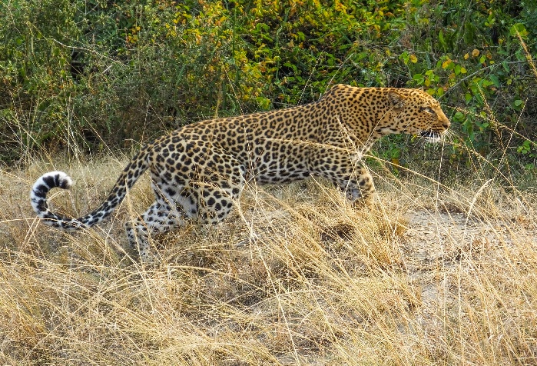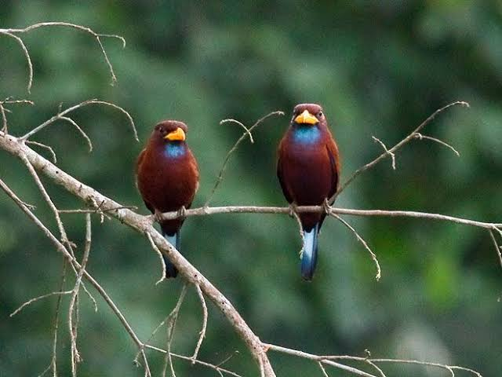
Leopard in Murchison falls NP Blue-throated Roller
Day 19: (August 17, 2023) “Whole day in the forest birding”. A pre-dawn starts in order to arrive early at Budongo Forest and the Royal Mile, a pristine forest reserve. Before entering the forest, we should see White-thighed Hornbill. Our main interest is locating forest species either on the forest floor or in the giant trees. We have good chances of locating Chocolate-backed and Dwarf Kingfishers, Brown-eared and Yellow-crested Woodpeckers, Grey Apalis, Forest Robin, Red-capped Robin-chat, Red-crested Malimbe, Grey Longbill, Rufous-crowned Eremomela, Green-backed Twinspot. As we pass through the forest, we find colonies of Yellow-backed Weaver. Dinner and overnight stay at Masindi Hotel.
Day 20: (August 18, 2023) “Travel to Murchison falls”. After breakfast, you drive northwards to Murchison Falls National Park birding through the Escarpment. Special birds include Western Banded Sunbird, Mocking Cliff-Chat, Yellow-fronted Tinkerbird, Grey-headed Bush-Shrike, Singing Cisticola, Namaqua Dove, Green-winged Pytilia, Crested Francolin, Northern, and Black-winged Red Bishops, Black-bellied Firefinch, Black-faced Waxbill, and March Tchagra. Afternoon game drive and birding towards Nile Delta look for White-faced Scops-Owl, Slender-tailed Nightjar, Greater Honeyguide, Scaly-throated Honeyguide, descend into the Rift Valley with views of Lake Albert and the Congo. As the habitat changes we may locate Brown Snake Eagle, White-bellied Go-away-bird, Foxy Cisticola, Red-winged Grey Warbler, and Brown-throated Wattle-eye. Overnight stay at Pakuba Safari Lodge or Fort Murchison Lodge.
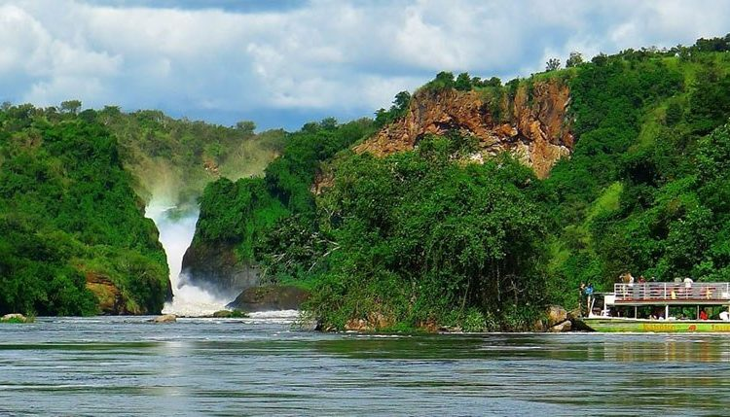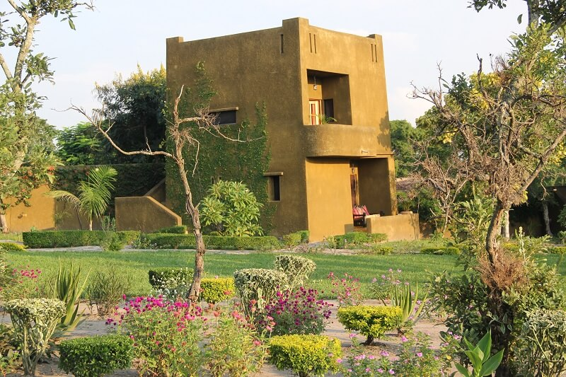
Murchison Falls – towards the bottom of the falls Fort Murchison Lodge
Day 21: (August 19, 2023) “Murchison Falls NP” Today morning we cruise up the Victoria Nile to the bottom of the falls and hike to the top of the falls. The hike to the top of the falls is combined with a boat ride to the bottom of the falls, giving you a double experience on the boat and during the hike (the top of the falls can also be reached by vehicle). If you take a Nile Cruise on the Victoria Nile, the cruise will take you to the trailhead of the hike known as Bakers Point/Trail. It is believed that this is where Sir Samuel Baker, a European explorer, stood and proclaimed Uganda the Pearl of Africa and it is this place that he called the Murchison Fall. Rocky forest specialties await Buff-bellied Warbler, Yellow-fronted Tinkerbird, Bar-breasted Firefinch, White-rumped Canary, Red-winged Gray Warbler, Spotted Thrush, Marabou Stork, Red-throated Bee-eater, Western Buzzard, Silverbird, Beautiful Sunbird, Black-headed Gonolek, Speckle-fronted Weaver, Gold-backed Weaver, White-rumped Seedeater, Pel’s Fishing Owl, White-crested Turaco, Bruce’s Green Pigeon, Chestnut-crowned Sparrow Weaver, Northern Carmine Bee-eater, Pennant-winged Nightjar, Standard-winged Nightjar. When you get to the top of the falls you will be amazed at how beautiful nature is as you have a full view of the park and the Nile as it transforms from the Victoria Nile to the Albert Nile, the sound of water, gushing out of the gorge, and as the falls cascade down a 150-foot cliff to the rocks and rebound, forming a rainbow and whitish snow. The rocks in the middle of the waters look out for pairs of Rock Pratincole.
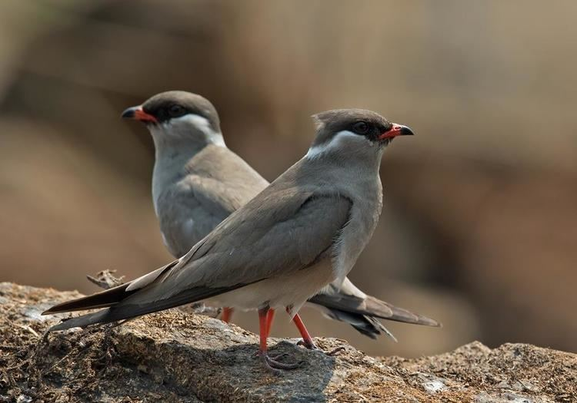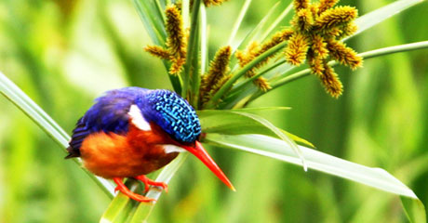
Rock Pratincole Malachite Kingfisher along the banks of River Nile
At midday return for lunch at the lodge and at 3 pm, we visit Albert Nile towards Lake Albert by boat, a haven for waterbirds. We should record Goliath Heron, Long-toed Lapwing, Senegal Thick-knee, and Blue-breasted Bee-eaters. Riverside banks and trees attract Northern Carmine and Swallow-tailed Bee-eaters. Murchison, with its abundant bird and mammal life, is our afternoon safari. Traveling along dirt tracks provides us with Crested and Heuglin’s Francolins, Black-bellied Bustards, and Flappet Lark, whilst the taller trees attract Striped Kingfisher, White-breasted Cuckoo-shrike, Bronze-tailed Starling, and Speckle-fronted Weaver. Red-necked Falcons and parties of wandering Abyssinian Ground Hornbills prefer areas of palms. Stunted bushes have the attractive Silverbird and grassy areas near the river host Grey-crowned Crane, Spotted Mourning Thrush, and Bar-breasted Firefinch. After early we go out for a night game drive in search of owls and nightjars, but during the drive, we may encounter predators too. Meals and overnight stay at Pakuba Safari Lodge or Fort Murchison Lodge)
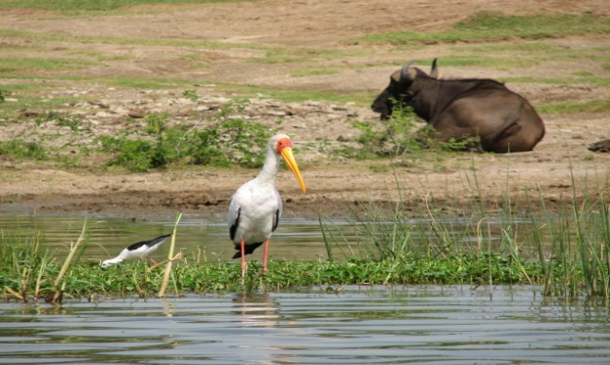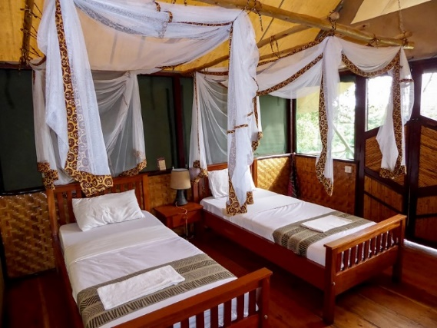
Yellow-billed stork The Bush Lodge Queen Elizabeth NP
Day 22: (August 20, 2023) After an early breakfast, we will have a morning game drive and birding. In the lush Borassus grassland, you may be spot species like the Secretary Bird, Abyssinian Roller, Ground Hornbill, Pied Kingfisher, Red-throated Bee-eater, Goliath Heron, Saddle-billed Stork, Sacred Ibis, Fulvous Whistling-Duck, Senegal Thick-knee, Black-headed Lapwing, Long-toed Lapwing, Little Bittern, Osprey, Red-necked Falcon, Blue-breasted Bee-eater, Vinaceous Dove and Grosbeak Weaver. And at 10:30 am travel to Entebbe for your homebound flight.
Mammals and primates encounters of this trip include; Mountain Gorilla, Grey-cheeked Mangabey, L’hoest Monkey, Golden Monkey, Velvet, and Blue Monkey, Red Colobus Monkey, Patus Monkey, Honeybadger, Hartebeests, Oribis, Uganda Kob, Zebras, Elephants, Giraffes, Bushbucks, Buffalos, Lions, Leopard, Spotted Hyena, Jackal, and Mongoose among others
This holiday is fully inclusive of accommodation, meals, bottled drinking water on the road, ground transport, fuel, boat trips, park entrance, rangers, gorilla permits, guiding, nature walks, night game drive/birding, and government taxes.
Not included in the package are; bar bills, insurance, items of a personal nature, air tickets, visas to enter Uganda, tips.

